

**SENSORS AND**

**AUTOMATION**

**Sarvesh Anand Mankar**

**142203013**

**SY Comp Div-2, S5 Batch**

**Practical-3: Characterization of Strain Gauge**

**Aim:**

1. Plot the characteristics of Strain gauge.
2. Understand the effect of various parameters on the strain gauge performance.

**Theory:**

Stress is the force generated inside an object in response to an applied external force.This internal force divided by the cross-sectional area of the object is called stress,which is expressed in Pa (Pascal) or N/m2.If the direction of the external force is vertical to the cross-sectional area, the stress is called vertical stress.

**Strain:** When a bar is pulled, it causes change in its length by ΔL, making its new length = L (original length) + ΔL (change in length). The ratio of this change in length ΔL, to the original length, L, is called strain. The strain is expressed in ε (epsilon): ε = ΔL / L Strain in the same direction as the external force is called longitudinal strain.Each material has a certain ratio of lateral strain to longitudinal strain.This ratio is called Poisson's ratio.

**Gauge Factor:**

The characteristics of the strain gauges are described in terms of its sensitivity (gauge factor). Gauge factor is defined as unit change in resistance for per unit change in length of strain gauge wire given as

G.F. = (ΔR/RG) / ε

where, ΔR - the change in resistance caused by strain, RG - is the resistance of the unreformed gauge, and ε - is strain.

### ****Arrangement:****

In certain applications where equal and opposite strains are known to exist it is possible to attach similar gauges in way that one gauge experiences positive strain and other negative strain. Depending on the number of gauges used the bridge, the circuit configurations are :

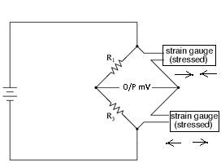

**Half Bridge**

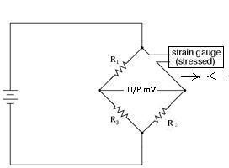

**Quarter Bridge**

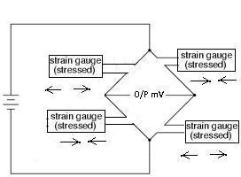

**Full Bridge**

**Pretest:**



**Selected Values:**

1. Material:Copper
2. Input Voltage :10
3. Resistance :600
4. Gauge Factor :2
5. Configuration :Full Bridge
6. Weight : 4 Kg
7. Output Voltage : 20.09

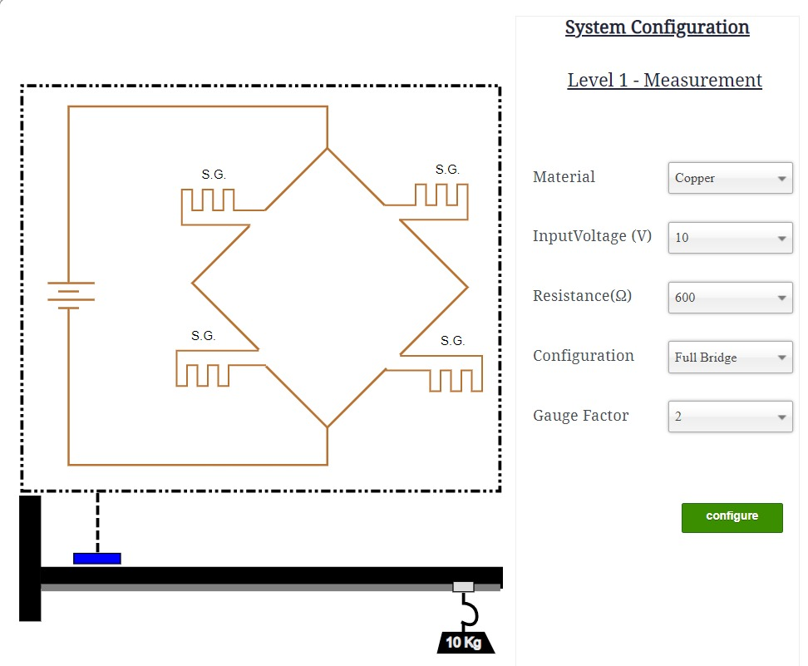

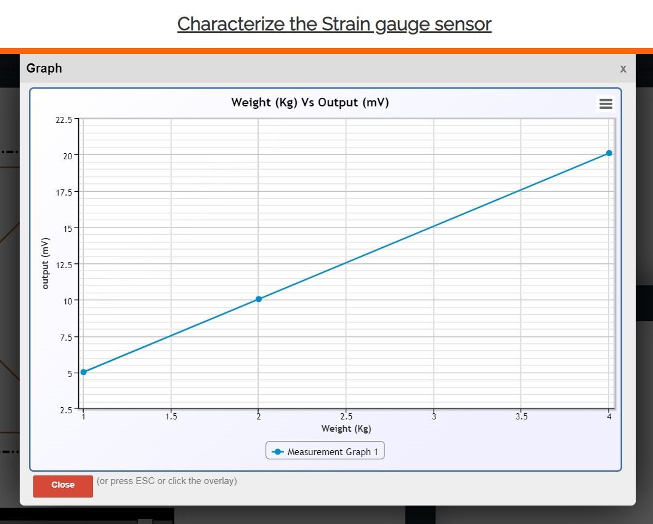

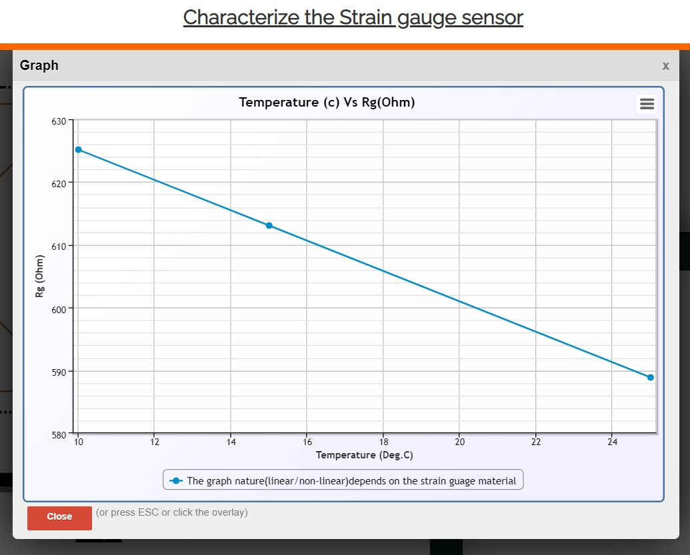

**Posttest:**



**Conclusion:**

We studied characteristics of Strain Gauge and effects of various parameters on it’s performance.